Specialization and Interdependence Energizer

Introduction: People who make goods and services are producers. Consumers are those who use the goods and services. Most people have jobs where they produce a specific good or service; they specialize. In this lesson students discover when people specialize, they become interdependent.

Grade Level: 2-4

Time Required: 10-20 minutes

Objectives:
- The student will participate in an activity demonstrating an understanding of specialization and interdependence.
- The student will review the economic concepts of consumer, producer, goods, and services.

Materials:
- Visual- Specialization and Interdependence
- Specialization and Interdependence name cards (run off on cardstock and strung with yarn to go around the student’s neck.)
- Yarn
- Optional- Extension Activity Cards

Economic Concepts:
- Consumer
- Goods
- Interdependence
- Producer
- Services
- Specialization

Procedure:
- Prepare and collect the materials prior to the activity.
- Introduce the lesson by quickly reviewing the featured economic concepts.
- Display the visual. Read the contents to the students. It works well if different students read the lines under the Artist, Cook, Farmer, and Clown.
- Read the directions for the Specialization and Interdependence Chain. Instruct the students to come forward and select the prepared card from the container.
- Explain that ARTIST will be the first person in the chain. The ARTIST card has BARBER as the second job; therefore, BARBER is second in the chain. BARBER is then followed by BUS DRIVER, and so on.
- Encourage students to follow the example from the visual and create a good or service that may be needed from the person next to them in the chain. For example, the ARTIST may want a haircut from the BARBER and the BARBER may want a ride from the BUS DRIVER.

Extension Activities-
- Students may create their own specialization card using the pattern provided. They may wish to use the four examples on the visual as models. They may draw a picture on the back of the card.
- Encourage students to add verses to the song “The Baker Wants a Pair of Shoes”.
[From- The Econ Song Book: Old Songs with an Economics Twist, Martha Hopkins 1997.]

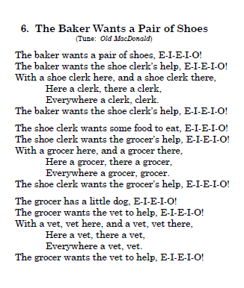

Visual-
Specialization and Interdependence Chain
EXAMPLE:


I am an ARTIST. I am a COOK. I am a FARMER. I am a CLOWN.
I am hungry. I am making a cake. I raise chickens. I want to advertise.
I would like a cake to eat. The cake needs eggs. The chickens are sad. I would like a new poster.
A COOK could help me. A FARMER could help me. A CLOWN could help them. An ARTIST could help me.

Artist-Barber
1

Activity Cards
Artist-Barber  1 | Grocer-Librarian  11
Barber-Bus Driver  2 | Librarian-Mail Carrier  12
Bus Driver-Carpenter  3 | Mail Carrier-Mechanic  13
Carpenter-Chef  4 | Mechanic-Nurse  14
Chef-Dentist  5 | Nurse-Plumber  15
Dentist-Electrician  6 | Plumber-Security Guard  16
Electrician-Farmer  7 | Security Guard-Teacher  17
Farmer-Fire Fighter  8 | Teacher-Trash Collector  18
Fire Fighter-Florist  9 | Trash Collector-Veterinarian  19
Florist-Grocer  10 | Veterinarian- Artist  20

Extension Activity-

I am a ____________________________.

I am _______________________________.

I would like _________________________.

A ____________________ could help me.

I am a ____________________________.

I am _______________________________.

I would like _________________________.

A ____________________ could help me.

