The Energetic Entrepreneur

Introduction: In this lesson, students will discover that having lots of energy is a characteristic that is beneficial to both the entrepreneur and the student.

Grade Level: 2-5

Time Required: 10-20 minutes

Objectives:
- The student will learn about the characteristics of an entrepreneur.
- The student will participate in a physical activity that reinforces the characteristics of an entrepreneur.

Materials:
- Visual- What it Takes to be an Entrepreneur
- Activity Cards- Run off on cardstock and cut into individual cards

National Standards
Standard 1: Scarcity. Productive resources are limited. Therefore, people cannot have all the goods and services they want; as a result they must choose something and give up others.
Standard 14: Entrepreneurship. Entrepreneurs take on the calculated risk of starting new businesses, either by embarking on new ventures similar to existing ones or by introducing new innovations. Entrepreneurial innovation is an important sources of economic growth.
Virginia Standards of Learning- Social Studies

Economic Concepts
- Scarcity—the condition of limited resources. Because resources are limited, people must make choices.
- Entrepreneur –The individual who comes up with an idea for a good or service and who organizes the human, natural, and capital resources to produce that good or service.
- Productive resources—the natural, human (labor), and capital resources used to produce a good or service.
- Goods—tangible products used by consumers or producers.
- Services—beneficial work which does not result in a tangible product—for example, haircuts and medical care.
- Profit—the difference between revenues and the costs entailed in producing or selling a good or service. Profit is the reward to a successful entrepreneur.

Procedure:
- Introduce the lesson by telling the students that this activity is based on the characteristics of an entrepreneur. Tell the students “An entrepreneur is a person who uses his or her skills and initiative to start a new business with the aim of making a profit. This person is often a risk-taker who sees opportunities when others do not.”
- Display the visual. Read the bulleted content listed with in the box making reference to the illustration and encouraging discussion. For example, “A hardhat for protection from falling prices” could also symbolize the need for the entrepreneur to have a hard head or maybe the entrepreneur is promoting a new product.
- Inform the students that they will now be doing an activity that reviews the characteristics of an entrepreneur.
- Instruct them to stand by their desks and to follow the directions on each of the displayed cards. Place the cards face down on a flat surface and pick up one at a time, display the picture and reading the command. Cards may be repeated thus pacing the activity to fill the allocated time. Note: Spelling m-o-n-e-y in sign language is challenging at first, but one the students follow your example several times; it turns out to be their favorite card.

Bonus Energizer:
If you think the statement is a characteristic of an entrepreneur standup, if you think it is not a characteristic of an entrepreneur sit down.

  - Sleeping until noon
  - Researching new ideas and current trends
  - Giving up easily
  - Being afraid to meet new people and do new things
  - Wanting to be your own boss
  - Sticking to a task until it is complete
  - Being creative
  - Wanting to get rich without working hard
  - Taking risks
  - Getting along with people
  - Making decisions
  - Forgetting to do things on time
  - Knowing about the good or service
  - Having the funds to finance a business
What It Takes to be an Entrepreneur
An entrepreneur is a person who uses his or her skills and initiative to start a new business with the aim of making a profit. This person is often a risk-taker who sees opportunities when others do not.

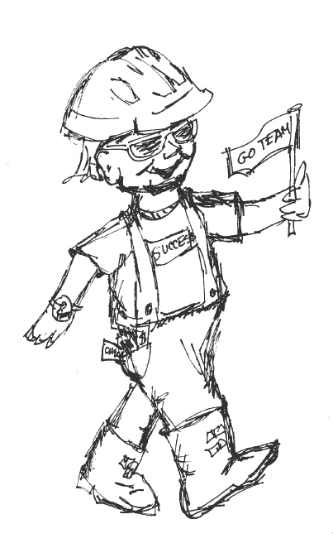

This entrepreneur has…
- A hardhat for protection from falling prices
- Waterproof boots for wading into unknown territory
- A big watch that allows for more hours in the day
- A pocket full of money to help finance a business
- Big ears to listen for good ideas
- A long neck for sticking out to take risks
- A t-shirt and flag that display a good attitude
- Special glasses that foresee opportunities and challenges

Activity Cards-
Tip your hat | Walk in place
Use your arms to show the time | Be still and listen

Turn Around-Look Around
Roll the Dice |   Wave the flag

