Aim: How can the level of spending be controlled in the economy?
Topic: Keynesian Economics

Document #1: Introduction to Keynesian Economics
John Maynard Keynes was an economist during the Great Depression. He believed that the best way to fix the economy was the manipulation of Aggregate Demand. He believed the “animal spirit of business” made businesses too hard to predict and control. While Keynes did agree that in the long run the economy will fix itself, he also famously stated, “in the long run, we are all dead.” Therefore, it was up to government spending and the manipulation of consumer spending to fix an economy in a timely fashion.

To accomplish this, Keynes proposed a series of formulas to demonstrate how consumers spend their money. These formulas will culminate in the idea of a multiplier effect: that based on the amount people spend, a government insertion of spending will actually have a greater multiplied effect than the amount they spend. Due to this, the government will also be able to balance its budget.

Keynes believes that focusing on Consumer Consumption is the most important part of looking at how to fix the economy. Keynes believes that prices and wages are not as flexible as Classicists say, and are instead known as sticky wages and sticky prices – they do not rebound as fast. Wages are sticky and the price level is not, so unemployment is less stable and predictable. Therefore, action must be done by the government to increase consumer spending.
Before an action can be taken by the government, though, the government must first be able to calculate consumer spending in order to calculate the amount of money that the government must spend. If the government knows how much people spend or save, the government will be able to predict the effects of increasing or decreasing government spending on the consumer and the economy.

Keynes created several formulas for this:

Keynes’ Average Propensity to Consume and Save
Average Propensity to Consume (APC): the average amount we will spend based on one dollar of income.
Formula: Ratio of consumption expenditures (c) to disposable income (DI), or APC = C/DI.

The average propensity to save (APS): the average amount we will save based on one dollar of income.
Formula: ratio of savings (S) to disposable income, or APS = S/DI

Marginal Propensities : change in consumption/saving due to a change in income
The Marginal propensity to Consume (MPC): is the change in consumption divided by the change in disposable income. It is a fraction of any change in DI that is spent on consumer goods.
Formula: MPC= change in C/change in DI
The Marginal Propensity to Save (MPS): is the fraction saved of any change in disposable income. The MPS is equal to the change in saving divided by the change in DI.
Formula: MPS = change in S/change in DI
MPC + MPS = 1
1) Why does Keynes disagree with letting the economy fix itself?
2) Why does Keynes not trust businesses to fix the economy?
3) Why is consumer spending the most important to Keynes?
4) Why and how does Keynes think the government should fix the economy?
5) Why is it important for a government to know how much people consume or save?
6) What is the difference between average propensity to consume and marginal propensity to consume?
7) What is the difference between the average propensity to save and the marginal propensity to save?
8) Why do you think the government is most interested in the MPC?
Document #2: From Consumption Function to the Aggregate Expenditure Model
In order to calculate the effect of government spending on the consumer and the economy, Keynes creates a series of graphs and graphical analyses to demonstrate his theory that an increase in government spending will have a multiplied effect throughout the economy.
First, the Consumption Function: The consumption function measures consumer spending compared to income. As income increases, so too, does consumer spending.
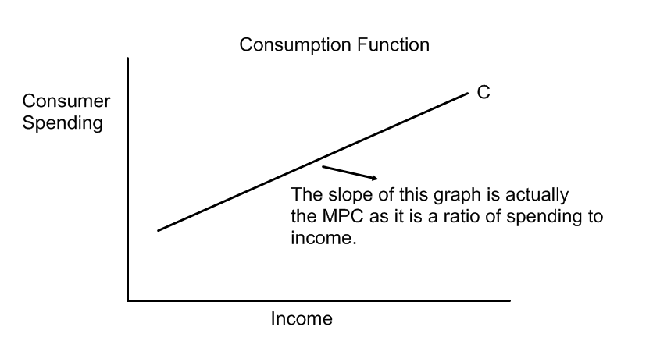
- It is important to know the spending patterns of people, which is why he came up with the MPC – Marginal Propensity to Consume – the likeliness of how much people will spend.
- The Consumption function shifts when accumulated wealth, expectations, household debt and taxes and government transfers either increase or decrease.
- Keynes then adds the Consumption Function to the rest of the total spending in the economy and comes up with the Aggregate Expenditure Graph (Total Expenditure Graph)
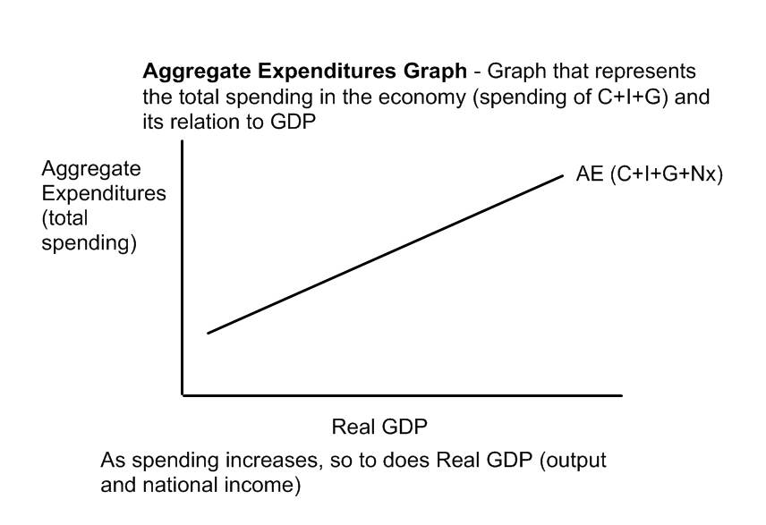
Aggregate Expenditure (or planned AE) = total spending in an economy = C+I+G +Nx.
Keynes believes that by using the mechanism of fiscal policy, the government can increase consumption and thus aggregate expenditure (total spending) and GDP.
1) Why is the consumption function upward sloping?

2) What are the factors that shift the consumption function? Why would these factors shift the consumption function?

3) Based on his theory of consumption, why would he say it is important to know the MPC?

4) What is the Aggregate Expenditures Graph? Why is it upward sloping?

Document #3: Building a complex aggregate expenditure graph and how government fixes the economy
Keynes believes:
1) There is a point where consumption = income – 45-degree ray on AE line
2) By using the mechanism/fiscal policy of government spending, can increase consumption and thus aggregate expenditure (total spending) and GDP.
Keynes developed the aggregate expenditure model to illustrate the effects of government spending on consumption.
Break even point – point in the economy where all earnings are spent – economy will gravitate toward this point. [where 45 degree ray (where income and spending are equal) meets AE curve]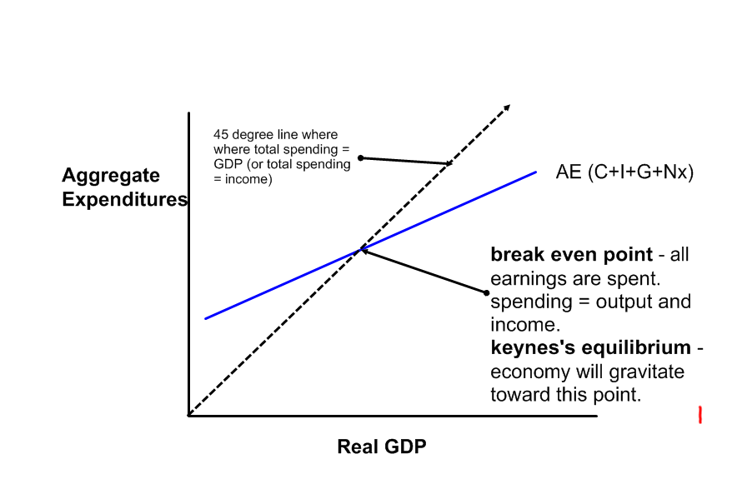
This graph can also show the different types of disequilibrium (and eventually how to fix it):
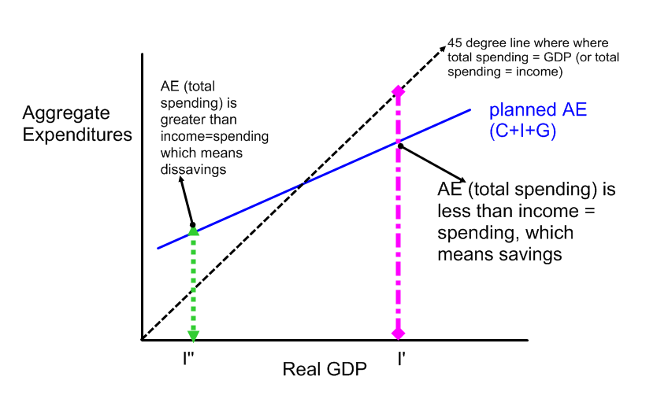
(note: on the Keynesian graph, recession and inflation are opposite to the LRAS graph)
I' - total spending (Aggregate Expenditures) is below the 45-degree ray (where spending=income), so that means that savings is taking place - people are spending less than income. (too little AE = recession)

I'' - total spending (Aggregate Expenditures) is above the 45-degree ray (where spending = income), so that means that dissavings is taking place -- people are spending more than income. (too much AE = inflation)
Keynes’ Natural Movement to equilibrium:
a) If the economy is operating at I’, savings are taking place, so inventories are piling up. Inventory accumulation causes producers to cut back production levels and let some workers go; income decreases; falling back to the break-even point of equilibrium.
b) If the economy is at I’’, where dissavings is occurring, inventories will be falling since spending is so great it is outstripping income. When inventories dwindle because spending is strong, producers respond by stepping up production levels. This means more workers will have to be hired and overall income in the economy will rise.
Keynes’ Recommendation for Government involvement:
Keynes is most concerned with getting the economy out of a recession: If the economy is operating at I’ (equilibrium is below where economy is), then there is a recession (too much savings) taking place. Keynes suggests that while the economy can gravitate back towards equilibrium, the government can actually shift the equilibrium to the current point in the economy by shifting the AE curve up (increasing AE). This is accomplished with government spending and what Keynes creates known as the multiplier effect.
The multiplier effect:
1) Government purchases labor + resources = creates jobs and money
2) People have more money = spending more = businesses have more workers
3) Businesses hire more workers = people have money to spend.
4) this all results in a shift of equilibrium and GDP.

****This is all known as the multiplier effect – shift in Aggregate Expenditure equals a larger shift in GDP due to the multiplied effect of one sector’s spending affecting the other parts of the economy.
Graphical example:
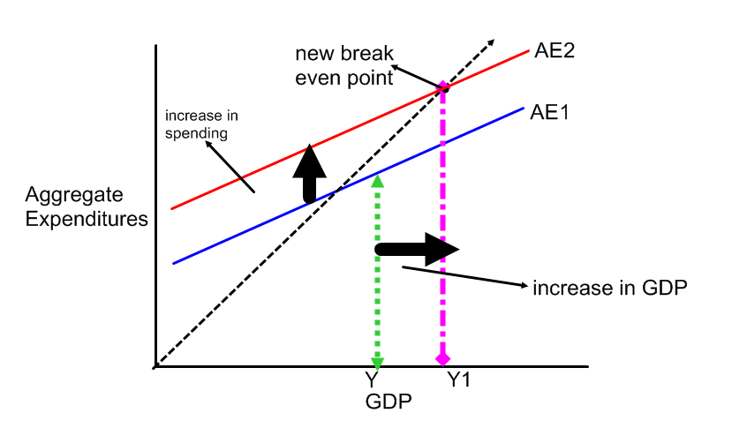
This would look the same as:
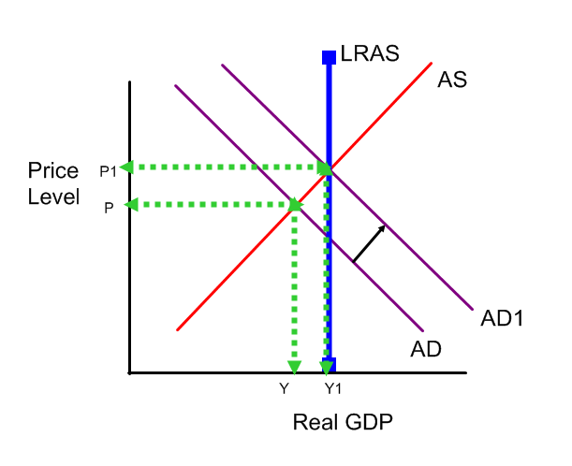
The increase in spending actually resulted in a greater or multiplied GDP.

1) How can the government increase Aggregate Demand/Aggregate Expenditures?
2) What does the 45 degree line show/mean?
3) What is the break-even point/Keynesian equilibrium?
4) Why do you think the economy will gravitate toward this point? Why does Keynes want it to?
5) What is the relationship of AE to 45 degree line at I’?

6) Why is a recession taking place?

7) How will this naturally move back to equilibrium?

8) What is the relationship of AE to 45 degree line at I’’?

9) Why is inflation taking place here?

10) How will this naturally move back to equilibrium?

11) According to Keynes, why would government spending be the best method to use to increase AE?

12) Why is this known as THE MULTIPLER EFFECT?

13) What happens on the AE curve and graph after the government increases government spending?

14) How does this relate to the LRAS AS/AD graph?

Document #4: How to calculate the Multiplier and the Balanced Budget Effect
The question then becomes if there is a multiplied effect, how much should the government spend so as to not overshoot the desired goal?
If the government knows the Marginal Propensity to Consume (which shows the changes in spending when income increases or decreases), this determines the multiplier and now:
a) Know how much of a change in output you can generate from government spending
b) Can determine how much you have to spend to close the gap and reach full employment/shift equilibrium.
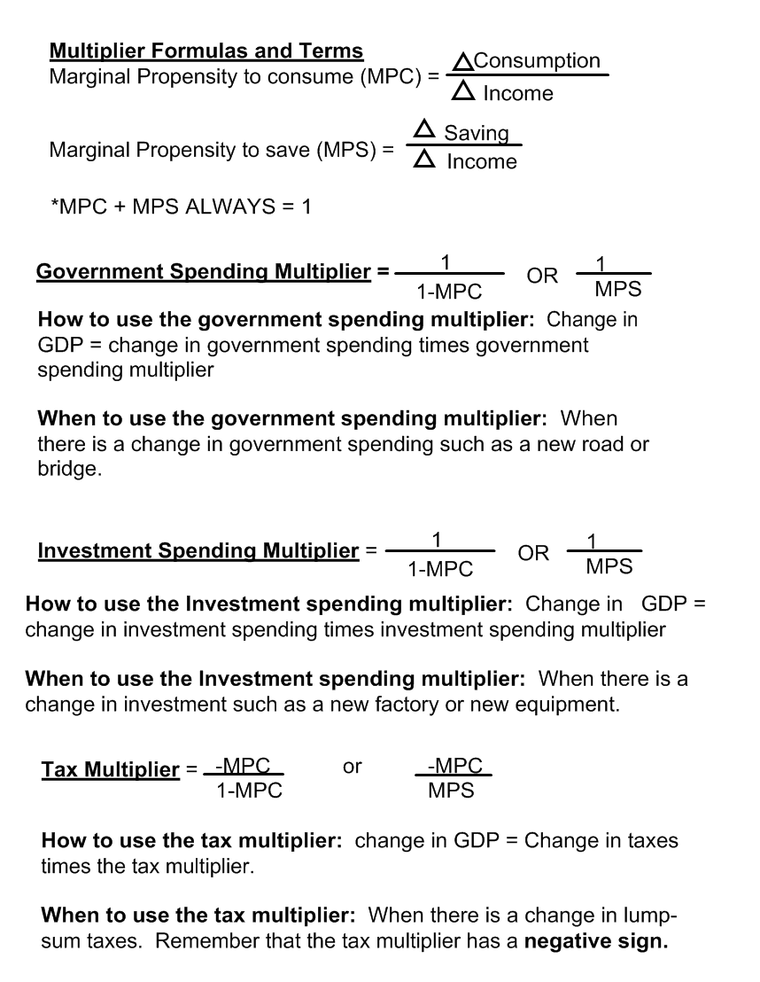
“Always Rules”
- The investment multiplier is always equal to the same value as the government spending multiplier
- The investment and government spending multipliers are always positive
- The tax multiplier is always negative
- The spending multiplier is always greater than the tax multiplier because consumers treat tax decreases as more disposable income, so they will save some of it.

Balanced Budget Multiplier – Is it possible to have a balanced budget?
The government both collects and spends tax revenue. In a simplified model, if the dollars spent equal the dollars collected, the budget is balanced. We have already discussed how the spending multiplier and tax multiplier are different. A quick example of a balanced budget policy illustrates what is called the balanced budget multiplier.
Example:
The government wants to spend $100 on a federal program and pay for it by collecting $100 in additional taxes. The MPC = .90 in this example.
Spending Effect:
When the MPC = .90, the spending multiplier = 10 because 1/(1-0.9) = 1/0.1 = 10!
This implies that a $100 of new spending (G) creates a $1,000 increase in real GDP.
Taxation Effect:
With society operating at the same MPC of .90, the tax multiplier is 9 because -.9/.1 = 9.
This implies that a $100 dollar increase in taxes decreases real GDP by $900.
Balanced Budget Effect
Change in real GDP = +$1,000 - $900 = +$100.
So a $100 increase in spending, financed by a $100 increase in taxes, actually (or only) created $100 in new GDP.
The balanced budget multiplier will always equal to one, regardless of MPC.
Balanced Budget Multiplier = 1.

1) Why is MPC used?

2) Why does MPC + MPS always equal 1?

3) Why do you think the government spending multiplier and investment multiplier are the same?

4) Although the government spending and investment spending multiplier are equal, why do you think Keynes recommends using government spending?

5) Why is the tax multiplier always negative?

6) Why is the spending multiplier always greater than the tax multiplier?

7) Based on the balanced budget formula, how is it possible for a government to balance its budget while generating an increase in GDP?

8) Why do you think the government does not do this more often?

When only have a graph with numbers or missing information:
1) figure out MPC of Consumption Function: MPC = rise over run of consumption function (point where C begins to equilibrium)
2) find out the multiplier based on this. Gov’t or investment = 1 divided by (1-MPC)
3) Can figure out amount needed to shift to new equilibrium = difference between current spot/equilibrium to new equilibrium/full employment divided by the multiplier.

