Aim: How do we create a working model for the health of our economy?
Topic: Aggregate Supply

Introduction to Aggregate Supply: Original Classical Theory
Document #1A: Say’s Law
We originally saw that supply is the ability and willingness to produce. French economist Jean Baptiste Say said, "Supply creates its own demand": When anything is produced, it generates an amount of income equal to its value. It is therefore impossible to produce too much because of this fact. When something is produced (supplied), it generates enough income to purchase (demand) the item.
Suppliers will always adjust to demand shocks, keeping output stable regardless of price level and eventually, stabilizing the price level, as they themselves are stabilized.
Two examples of this are:
- inflation: price level gets too high and people are not buying, then inventories build up and businesses must lower prices.
- recession: people are not buying enough, price level gets too low, people will buy more, output will remain constant and/or businesses will expand and compete for workers, hiring them, raising wages and increasing spending.

1) What is Say’s Law?

2) According to Say’s Law, why will suppliers always adjust to the demand shocks?

3) Do you agree or disagree with Say’s Law? Explain.

Document #1B: Classical Application of Say’s Law
Classical economists believe that because supply regulated itself, therefore government should just leave suppliers and the economy alone (laissez-faire economics) or simply focus on supply-side economics -- helping suppliers in their ability and willingness to produce. This was the model that economists and government followed for the late 19th and early 20th century, however in 1929, there was a problem. During the Great Depression, there were very low price levels, but still no increase in demand or a natural stabilization of the economy. GDP was still very low.
- Based on what determines the amount of output, why would Classical Economists believe that supply-side policy is best? Do you agree or disagree? Why?

2) Why does the Great Depression represent a problem for Classical theorists?

Document #3: John Maynard Keynes’ model and then the new intermediate model.
Keynes disagreed that supply is completely responsive, and instead said that supply is dependent on demand. This theory, proved too unresponsive to changes, especially due to the fact that Keynes believed in a theory called sticky prices and wages – prices and wages do not change as flexibly or rapidly as Classicists say. Two new intermediate theory was created – Short Run Aggregate Supply and Long-Run Aggregate Supply.
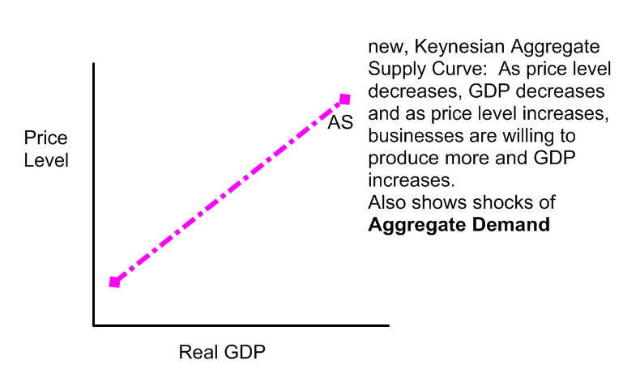

Intermediate Analysis:
The Keynesian Aggregate Supply Curve is not the long run aggregate supply. Rather, this is called Short Run Aggregate Supply - this is how the economy behaves in the short run. Price level and demand shocks do affect GDP and quantity supplied in the short run. The SRAS (or just AS) shows the relationship between the total quantity of output supplied by all firms and the price level. It measures the total supply of all goods and services in the economy that firms are willing and able to produce for the economy over the short run. It also solves the issue represented during the Great Depression – when Price Level is low, businesses are not willing to produce as much, since they won’t make as much of a profit. However, when the price level is higher, businesses would be willing to produce more. In terms of SRAS, it is best to associate Price Level with profit/profit motive.
Because SRAS is the willingness and ability of all businesses to produce; it is assuming that the quality, quantity, costs and expectations of resources and technology are constant. However, just like aggregate demand, these factors will change and thus supply will change regardless of current price level.
Shifts in the Aggregate Supply Curve
SRAS is mostly affected by the costs doing business. (These factors may either cause an increase in AS (shift to the right) or a decrease (shift to the left). Remember, changes (shifts) in SRAS are due to changes regardless of price level.
Factors that Shift SRAS
- Costs of inputs (including wage rate)
- Expectations of future prices:
- When businesses expect an increase in prices/price level - shift to left and decrease supply in the short term, waiting for prices to rise.
- if they expect a decrease in prices, shift to right and produce more in the short term, earning more profit now before prices get lower.
****remember, changes in prices will affect input costs as unions will build expectations of prices into wages and pensions and thus affect input costs****
- Tax policies aimed at producers
- Political or environmental phenomenon
- Exchange Rate (if it is cheaper or more expensive to import resources)
- Resource Availability (including labor, capital, natural resources)
- Technology
- Productivity

*AS shifts with LRAS when there is changes in the quality or quantity of resources and technology/productivity (because this will affect both long and short term ability and willingness to produce), and shifts by itself for all others (such as input costs which only affects the short term ability and willingness to produce)

- Why did the old model of short run aggregate supply not work?

- What is Short Run Aggregate Supply?

- Why does the SRAS schedule have a direct relationship between Price Level and GDP?

3) Why must we assume that the quality, quantity, costs and expectations of resources and technology are constant in the short run?

4) For each factor that shifts SRAS, why would this factor change the ability and willingness of businesses to produce in the short term regardless of price level (shift SRAS?)

Document #4: Long Run Aggregate Supply
Long Run Aggregate Supply also exists at the same time as Short Run Aggregate Supply, but represents a country’s ability and willingness to produce and its production possibilities over the long term. It is vertical, because over the long term, if all resources are being fully employed GDP will be stable regardless of prices. We want to be producing (where AS/AD meet) where resources are fully employed (on the LRAS) (see graph on bottom).

LRAS represents when the economy operates at full employment (natural unemployment rate of 4%) and full employment of resources; this is where the economy (and GDP) is fully responsive to price level changes. SRAS and LRAS both operate at the same time, but when Aggregate Demand or Aggregate Supply shift (due to shocks in the economy), they can move the economy away from equilibrium. It is the goal of economists and governments to achieve the point where AD/SRAS and LRAS meet. However, conservatives (or neo-liberals) believe it is best to focus on SRAS/LRAS policies to achieve equilibrium or to leave the economy alone, and SRAS will over the long-run return to equilibrium, whereas liberals believe it is best to manipulate AD to achieve equilibrium.

Shifts of the long-run aggregate supply curve can be brought about by such things that change a nation’s ability and willingness to produce over the long-term or permanently. The main two determinants are the change in the quality/quantity of resources and technology. While changes in aggregate supply determinants and resulting shifts of the long-run aggregate supply curve are less dramatic than changes affecting aggregate demand, they DO change. In most cases the changes are slow and steady, for example, the natural growth of the population and steady investment in capital resources. From time to time, however, shifts in the long-run aggregate supply curve are more abrupt, such as energy shortages during the 1970s.

The long-run aggregate supply curve is shifted due to changes by any (ceteris paribus) factor other than the price level. Two broad determinant categories include:
- Resource/Technology Quantity: This determinant is the quantity of the resources--labor, capital, land, and entrepreneurship--that the economy has available for production. If the economy has more resources, then aggregate supply increases and the long-run aggregate supply curve shifts rightward. With fewer resources, aggregate supply decreases and the long-run aggregate supply curve shifts leftward. Specific determinants in this category include population growth, labor force participation, capital investment, and exploration.

- Resource/Technology Quality: This determinant is the quality of resources, especially technology and education. If the quality of labor, capital, land, and entrepreneurship change, then the long-run/permanent ability/willingness to supply changes and the long-run aggregate supply curve shifts. An improved quality increases aggregate supply, triggering a rightward shift of the long-run aggregate supply curve, and a decline in quality decreases aggregate supply, generating a leftward shift of the long-run aggregate supply curve.
***When LRAS is affected by changes in the quality/quantity of resources/technology

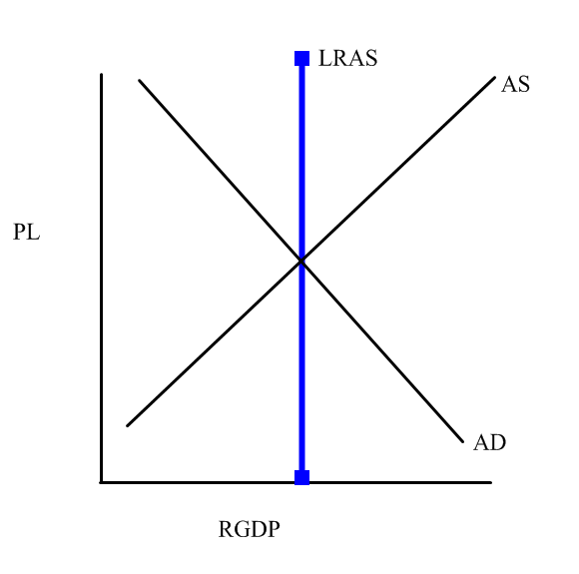

1) How are LRAS and SRAS similar and different?

2) What shifts LRAS? Why do these factors shift LRAS? How is it similar to PPC?

3) What is the difference between conservatives and liberals over LRAS and equilibrium? Which ideology do you think is better? Why?

