Curious George Rides a Bike
Specialization Lesson

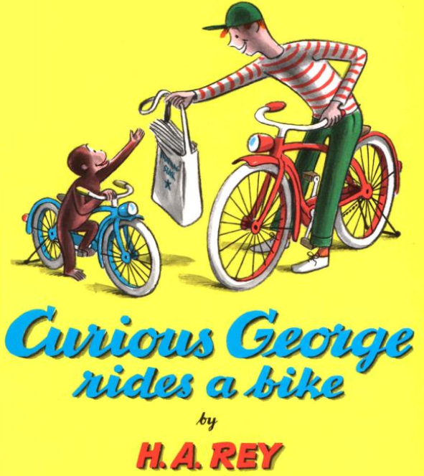
Introduction: Students discover that through specialization, production increases.
When producers specialize, they become interdependent and rely on one another to produce the goods and services that are wanted.
In this lesson students participate in a simulation where they compare the experience making a product on their own and in a group. (Self-sufficiency vs. Interdependence)

Objective:
The student will recognize that because people and regions cannot produce everything they want, they specialize in producing some things and trade for the rest.

Materials:
- Newspapers
- Tape
- Direction Sheets
- Optional: copy of Curious George Rides a Bike by H.A. Rey

Procedure:
- Introduce the lesson by telling the students that specialization is when producers make only one type of good or provide only one type of service. The baker bakes cakes, pies and bread. She does not try to build bicycles or ships. Economic specialization occurs when producers make fewer types of goods and services than they consume. Explain that interdependence is when produces begin to specialize they rely on other producers to help create goods and services that they do not make for themselves. Relying on each other makes produces interdependent.
- Tell the students that they will be making an item using newspaper. (This lesson works well when the book Curious George Rides a Bike is used as a literary tie-in.)
- Display a completed model of the either the hat or boat to the students. Distribute a piece of newspaper to each student and tell them to recreate the object they have just been shown. Wait for moans, confusion and frustration as multiple students tell you “this is not fair”.
- Ask the students to tell you what would help them complete the assignment. (Possible responses include: A direction sheet. An example. A demonstration. Some tools.)
- Distribute selected direction sheets to each student. Allow them to use the directions to create their own product. Note the length of time needed to complete the product.
- Organized the students into small groups (No group should have more than four members.) Give each group four sheets of newspaper and tape if required. Tell them that they have a few minutes to organize a system for creating their product. Every member of the group must have some part in the process and do the same job for every product.
- Tell the students they may start making their products.
- Call “time” when most groups have finished. (In most cases a team making four products takes about the same amount of time as an individual making one.)
- Discuss how team work is an example of interdependence.

